Linear Regression

a <- read.csv("train.csv")

> View(a)

> b<- lm(t~count+casual,data=a)

> print(b)

Call:

lm(formula = t ~ count + casual, data = a)

Coefficients:

(Intercept) count casual

17.007032 0.005915 0.058040

> plot(b)

Hit <Return> to see next plot: return(b)

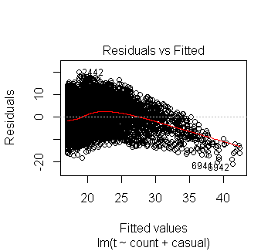

Hit <Return> to see next plot: c<-lm(t~.-datetime,data = a)

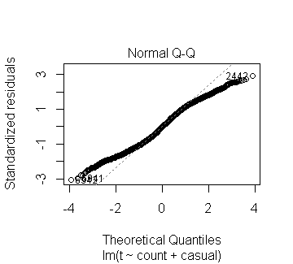

Hit <Return> to see next plot: print(c)

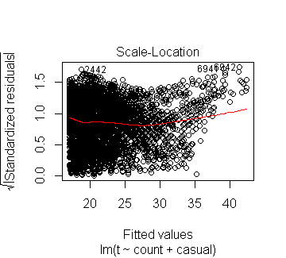

Hit <Return> to see next plot: summary(c)

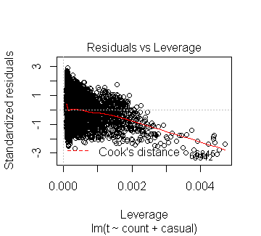

summary(t~count\*weather,data=a)

Length Class Mode

3 formula call

> names(c)

NULL

> summary(c)

Min. 1st Qu. Median Mean 3rd Qu. Max.

0.3617 0.3617 0.3617 0.3617 0.3617 0.3617

> effects(b)

(Intercept) count casual

-2.110807e+03 3.206537e+02 2.188541e+02 -7.269565e+00 -7.017460e+00 -7.017460e+00 -7.963901e+00 -8.729601e+00

-7.119336e+00 -4.296748e+00 -2.208569e+00 -3.990968e+00 -1.878224e+00 -1.382142e+00 -7.305395e-01 -1.875563e+00

-2.654712e+00 -1.136658e-01 -3.818806e-01 -2.130331e-01 -1.328322e+00 -8.344509e-01 -1.280746e+00 8.728488e-01

1.666400e+00 1.027142e+00 2.547171e-01 1.852311e+00 1.870152e+00 3.565929e-01 -4.574602e-01 -4.990888e-01

-1.450699e+00 -2.828431e+00 -3.471754e+00 -3.849522e+00 -3.200253e+00 -2.683372e+00 -4.496283e+00 -3.905706e+00

-3.719795e+00 -3.009173e+00 -3.970169e+00 -4.983582e+00 -7.038587e+00 -7.065036e+00 -7.879089e+00 -7.861248e+00

-1.474643e-01 4.923478e-02 3.734088e-02 -9.701251e-01 3.243497e-01 -6.034730e-01 -5.864098e-01 -9.430512e-01

[ reached getOption("max.print") -- omitted 9886 entries ]

attr(,"assign")

[1] 0 1 2

attr(,"class")

[1] "coef"

> coef(b)

(Intercept) count casual

17.007031924 0.005914777 0.058039870

> confint(b)

2.5 % 97.5 %

(Intercept) 16.819811350 17.194252499

count 0.004933203 0.006896351

casual 0.054480922 0.061598817